# Analysis of successful putts from various distances of professional golfers

We are analysis successful putts from various distances of professional golfers. The data is given to us in a form of distance, no of tries for that distance, and number of successes for that distance.

It was chosen to compare 4 generalised linear models where for both we have considered the response variable to be the number of successes, which naturally fits binomial distribution:

$y_{i}\sim Bin\left(n,p_{i}\right), logit\left(p_{i}\right)=α$

$y_{i}\sim Bin\left(n,p_{i}\right), logit\left(p_{i}\right)=α+βx_{i}$

$y_{i}\sim Bin\left(n,p_{i}\right), logit\left(p_{i}\right)=α+β_{1}x_{i}+β_{2}x_{i}^{2}$

$y_{i}\sim Bin\left(n,p_{i}\right), logit\left(p_{i}\right)=α+β_{1}x_{i}+β_{2}x_{i}^{2}+β_{3}x_{i}^{3}$

Full Code can be found in Appendix where JAGS code for Models can be found at golfers_bin1.model, golfers_bin2.model. R code is at R Code.

Both models were created using three chains and samples were drawn using 10000 iterations.

For each of the models, we have generated DIC values and Table 1 contains the results.

|  |  |
| --- | --- |
| Model | DIC |
| Model 1 | 2520 |
| Model 2 | 365.9 |
| Model 3 | 185.8 |
| Model 4 | 155.4 |

Table 1. DIC Values

In this case the clear choice is Model 4 due to lowest DIC value.

Mean values for each of the parameters are:

$$α=-0.91774648$$

$$β_{1}=-0.12141928$$

$$β_{2}=0.01365918$$

$$β_{3}=-0.00156764$$

The next step was to run cross-correlation. We can see on Figure 1 that there is a strong negative correlation between $α$ and $β_{2}$, and between $β_{1}$ and $β_{3}$. One approach to fix this is to potentially do reparameterization which is not done for this analysis due to the low DIC value.

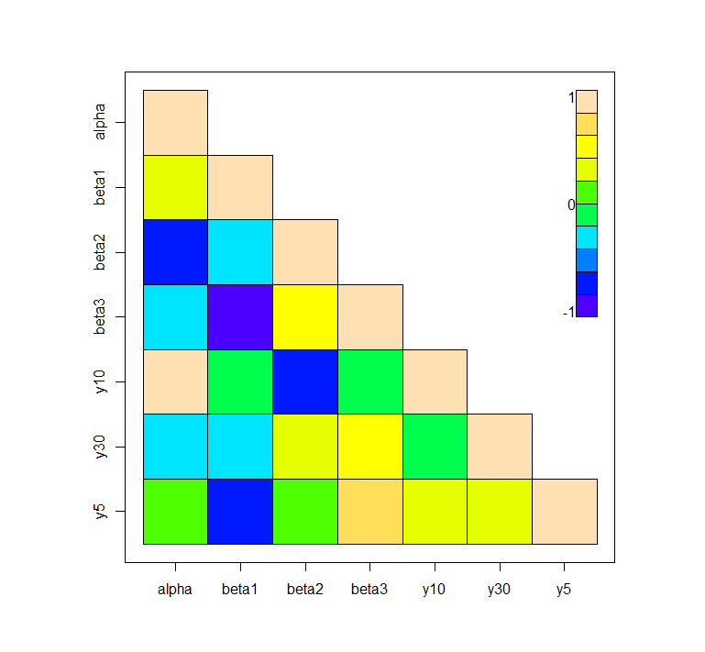

Figure 1. Cross Correlation Plot

Finally, we have completed estimates of proportion of success for 5, 10 and 30 feet distance attempts and the results are in the Table 2 including 95% credible interval.

|  |  |  |
| --- | --- | --- |
| Distance | Estimate | 95% credible interval |
| 5 | 0.65491896 | (6.329279e-01, 0.676514972) |
| 10 | 0.31418449 | (2.931234e-01, 0.335689129) |
| 30 | 0.00070438 | (2.436157e-06, 0.004912875) |

The estimates for 5 and 10 feet are slightly higher than the numbers we have from the input data (0.589 and 0.335) and are out of credible interval which brings us to believe that we could parameterize this model to improve it.

# Appendix

## R Code

require(rjags)

# the data

golfers_data=read.delim("golfers.dat")

golfers_data$ProportionSuccess = golfers_data$Successes / golfers_data$Tries

golfers.data = list(

N=nrow(golfers_data),

Distance=golfers_data$Distance,

Tries=golfers_data$Tries,

Successes = golfers_data$Successes)

# Models and sampling

golfers.model_bin1=jags.model("golfers_bin1.model", golfers.data, n.chains=3)

golfers.samps_bin1=coda.samples(golfers.model_bin1,variable.names=c("alpha", "y5", "y10", "y30"),1e4)

golfers.model_bin2=jags.model("golfers_bin2.model", golfers.data, n.chains=3)

golfers.samps_bin2=coda.samples(golfers.model_bin2,variable.names=c("alpha","beta", "y5", "y10", "y30"),1e4)

golfers.model_bin3=jags.model("golfers_bin3.model", golfers.data, n.chains=3)

golfers.samps_bin3=coda.samples(golfers.model_bin3,

variable.names=c("alpha","beta1", "beta2", "y5", "y10", "y30"),1e4)

golfers.model_bin4=jags.model("golfers_bin4.model", golfers.data, n.chains=3)

golfers.samps_bin4=coda.samples(golfers.model_bin4,

variable.names=c("alpha","beta1", "beta2", "beta3",

"y5", "y10", "y30"),1e4)

# DIC

golfers.dic_bin1 = dic.samples(golfers.model_bin1, 1e4)

golfers.dic_bin2 = dic.samples(golfers.model_bin2, 1e4)

golfers.dic_bin3 = dic.samples(golfers.model_bin3, 1e4)

golfers.dic_bin4 = dic.samples(golfers.model_bin4, 1e4)

golfers.dic_bin1

golfers.dic_bin2

golfers.dic_bin3

golfers.dic_bin4

# Sumamry statistics

golfers.summary_bin1 <- summary(golfers.samps_bin1)

golfers.means_bin1 <- golfers.summary_bin1$statistics[,"Mean"]

golfers.summary_bin2 <- summary(golfers.samps_bin2)

golfers.means_bin2 <- golfers.summary_bin2$statistics[,"Mean"]

golfers.summary_bin3 <- summary(golfers.samps_bin3)

golfers.means_bin3 <- golfers.summary_bin3$statistics[,"Mean"]

golfers.summary_bin4 <- summary(golfers.samps_bin4)

golfers.means_bin4 <- golfers.summary_bin4$statistics[,"Mean"]

# Print means

golfers.means_bin1

golfers.means_bin2

golfers.means_bin3

golfers.means_bin4

# Print quantiles

golfers.summary_bin1$quantiles

golfers.summary_bin2$quantiles

golfers.summary_bin3$quantiles

golfers.summary_bin4$quantiles

par(mfrow=c(1,1))

crosscorr(golfers.samps_bin4)

crosscorr.plot(golfers.samps_bin4)

## golfers_bin1.model

model{

for (i in 1:N){

Successes[i] ~ dbin(p[i], Tries[i])

logit(p[i]) <- alpha

}

alpha ~ dnorm(0, 0.0001)

p_temp5 <- alpha

p_temp10 <- alpha

p_temp30 <- alpha

y5 <- 1 / (1 + exp(-p_temp5))

y10 <- 1 / (1 + exp(-p_temp10))

y30 <- 1 / (1 + exp(-p_temp30))

}

## golfers_bin2.model

model{

for (i in 1:N){

Successes[i] ~ dbin(p[i], Tries[i])

logit(p[i]) <- alpha + beta*(Distance[i]-mean(Distance[]))

}

alpha ~ dnorm(0, 0.0001)

beta ~ dnorm(0, 0.0001)

p_temp5 <- alpha + beta*(5-mean(Distance[]))

p_temp10 <- alpha + beta*(10-mean(Distance[]))

p_temp30 <- alpha + beta*(30-mean(Distance[]))

y5 <- 1 / (1 + exp(-p_temp5))

y10 <- 1 / (1 + exp(-p_temp10))

y30 <- 1 / (1 + exp(-p_temp30))

}

## golfers_bin3.model

model{

for (i in 1:N){

Successes[i] ~ dbin(p[i], Tries[i])

logit(p[i]) <- alpha + beta1*(Distance[i]-mean(Distance[])) + beta2*pow(Distance[i]-mean(Distance[]),2)

}

alpha ~ dnorm(0, 0.0001)

beta1 ~ dnorm(0, 0.0001)

beta2 ~ dnorm(0, 0.0001)

p_temp5 <- alpha + beta1*(5-mean(Distance[])) + beta2*pow(5-mean(Distance[]),2)

p_temp10 <- alpha + beta1*(10-mean(Distance[])) + beta2*pow(10-mean(Distance[]),2)

p_temp30 <- alpha + beta1*(30-mean(Distance[])) + beta2*pow(30-mean(Distance[]),2)

y5 <- 1 / (1 + exp(-p_temp5))

y10 <- 1 / (1 + exp(-p_temp10))

y30 <- 1 / (1 + exp(-p_temp30))

}

## golfers_bin4.model

model{

for (i in 1:N){

Successes[i] ~ dbin(p[i], Tries[i])

logit(p[i]) <- alpha + beta1*(Distance[i]-mean(Distance[])) + beta2*pow(Distance[i]-mean(Distance[]),2) + beta3*pow(Distance[i]-mean(Distance[]),3)

}

alpha ~ dnorm(0, 0.0001)

beta1 ~ dnorm(0, 0.0001)

beta2 ~ dnorm(0, 0.0001)

beta3 ~ dnorm(0, 0.0001)

p_temp5 <- alpha + beta1*(5-mean(Distance[])) + beta2*pow(5-mean(Distance[]),2) + beta3*pow(5-mean(Distance[]),3)

p_temp10 <- alpha + beta1*(10-mean(Distance[])) + beta2*pow(10-mean(Distance[]),2) + beta3*pow(10-mean(Distance[]),3)

p_temp30 <- alpha + beta1*(30-mean(Distance[])) + beta2*pow(30-mean(Distance[]),2) + beta3*pow(30-mean(Distance[]),3)

y5 <- 1 / (1 + exp(-p_temp5))

y10 <- 1 / (1 + exp(-p_temp10))

y30 <- 1 / (1 + exp(-p_temp30))

}